**PART ONE**

A sample dataset of 1000+ transactions were used

Trend of sales in a local shop

* **Data preparation and exploration**

**PART TWO**

* **Trends in sales**

**PART THREE**

* **Visualisation and Modelization**

**PART FOUR**

* **Interpretations and recomendations**

**Data preparation**

* **A dataset was downloaded from kraggle**
* 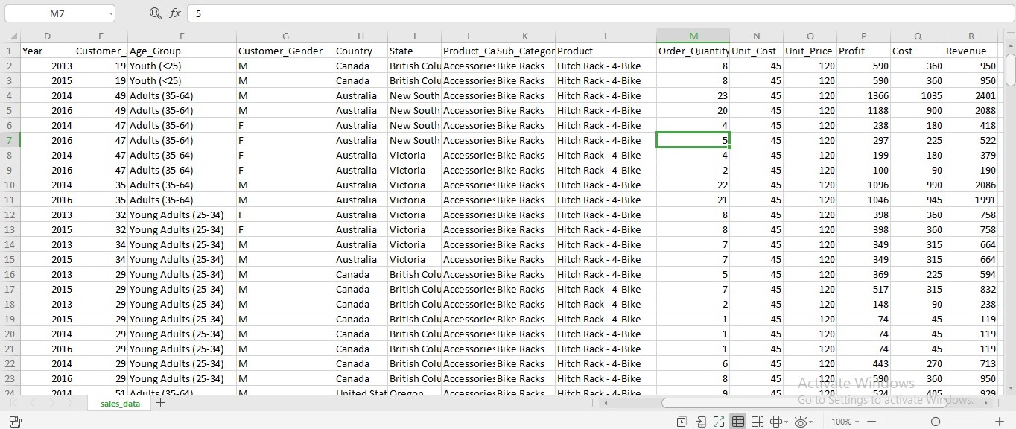**This dataset was re-arranged in an excel sheet to match sweetible description of ODC required dataset**
* **Imported this file to jupyter notebook using a code as illustrated in screenshot below**

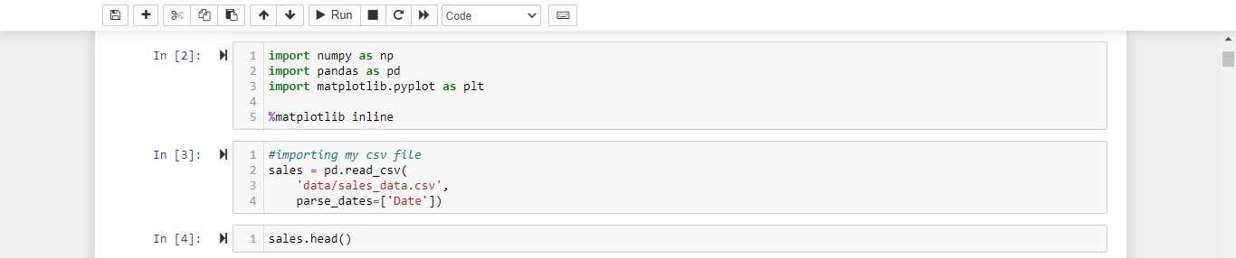

**EXPLORATION**

* **I calculated the mean of quantity ordered each time and noticed customers always order 2 products each time**
* **This is illustrated in graph below**

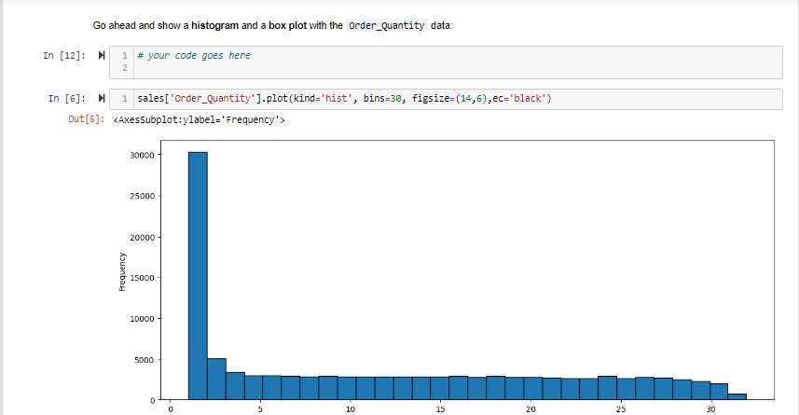

**TRENDS IN SALES**

* I noticed from the period 2011 to 2012 there was an increase in the sales
* And equaly from 2012 to 2015
* These sales reduced from 2015 to 2016
* But the highest year which recorded the highest sales is 2014
* A pie chart was designed to illustrate this trend as shown below

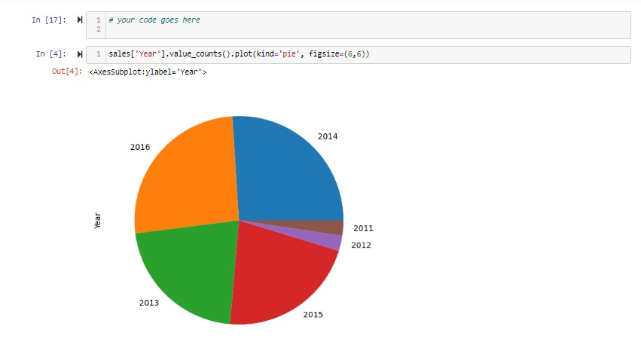

VISUALISATION

* Most sales were made in countries as follows
  + USA
  + Australia
  + Canada
  + United Kingdom
  + Germany
  + France
* This is demonstrated in the graph below

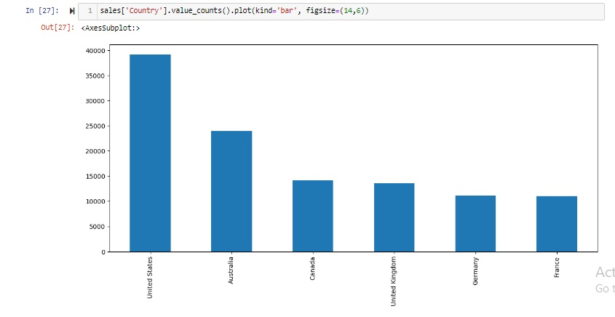

* And to contintue on these productivity and good sale rates
* More sales point have to be opened in other countries
* Promotions can be carried out in other countries with less sales

MODELING

* From the data gathered, we notice the highest selling product are bike racks in the last few years and makes highest sales every season
* For the next two years the next few years bike rack has an estimated sale of 20,000
* In the next five taers to come, bike stacks will still be the most sold product and will have a range of demand 10,000 to 20,000

INTERPRETATION AND RECOMMENDATIONS

* In countries such as USA with a vast population there are more sales
* In countries situated in Europe there is less sale due to maybe
* Differences in language
* Less sales point
* Improper access to facilities

I would recommend the following

* More sales points should be openened in most areas
* Translators can be employed in various sales points
* Reach more population by using social media
* Give out discounts to best clients
* Concentrate more on bike racks since it’s the most sold product